|  |  |  |  |  |  |
| --- | --- | --- | --- | --- | --- |
| Name: | ___________________________________________ | | | | Date:*__________* |
| pact jpg1 | **Subject: METHODS MAT**  **Investigation 2, 2015**  **Topic – Arithmetic and geometric sequences**  **Take home component** | | | |  |
| **Important Information:**  *Although the take-home component is not worth any marks, it is essential in preparation for the in-class component. Knowledge and skills gained will be extended in the in-class validation component. This in-class validation will be completed under test conditions on the day in which this take-home component is due. The take-home component may be used when completing the in-class component. Contact may be made to parent(s) if the take-home component is not available for submission (at the start of the lesson).* | | | | | |
| **Date out:** | | *Week ____ Date __________* | **Date Due:** | *Week ____ Date _________* | |
| **Take home component weighting:** | | *0% of the year* | **In-class component weighting:** | *5% of the year.* | |
| **AIM:** This investigation consists of activities which allow students to develop an understanding of the way sequences can be used to determine area. | | | | | |



An architect for a local council decided that titanium sheeting 2 mm in thickness would be used to cover the front of a memorial wall which was 25 m long. The wall is to be made in two parts as shown in the diagram, below and the titanium covering will be made of individual sheets which are attached to the wall and for which there is no overlapping of sheets.

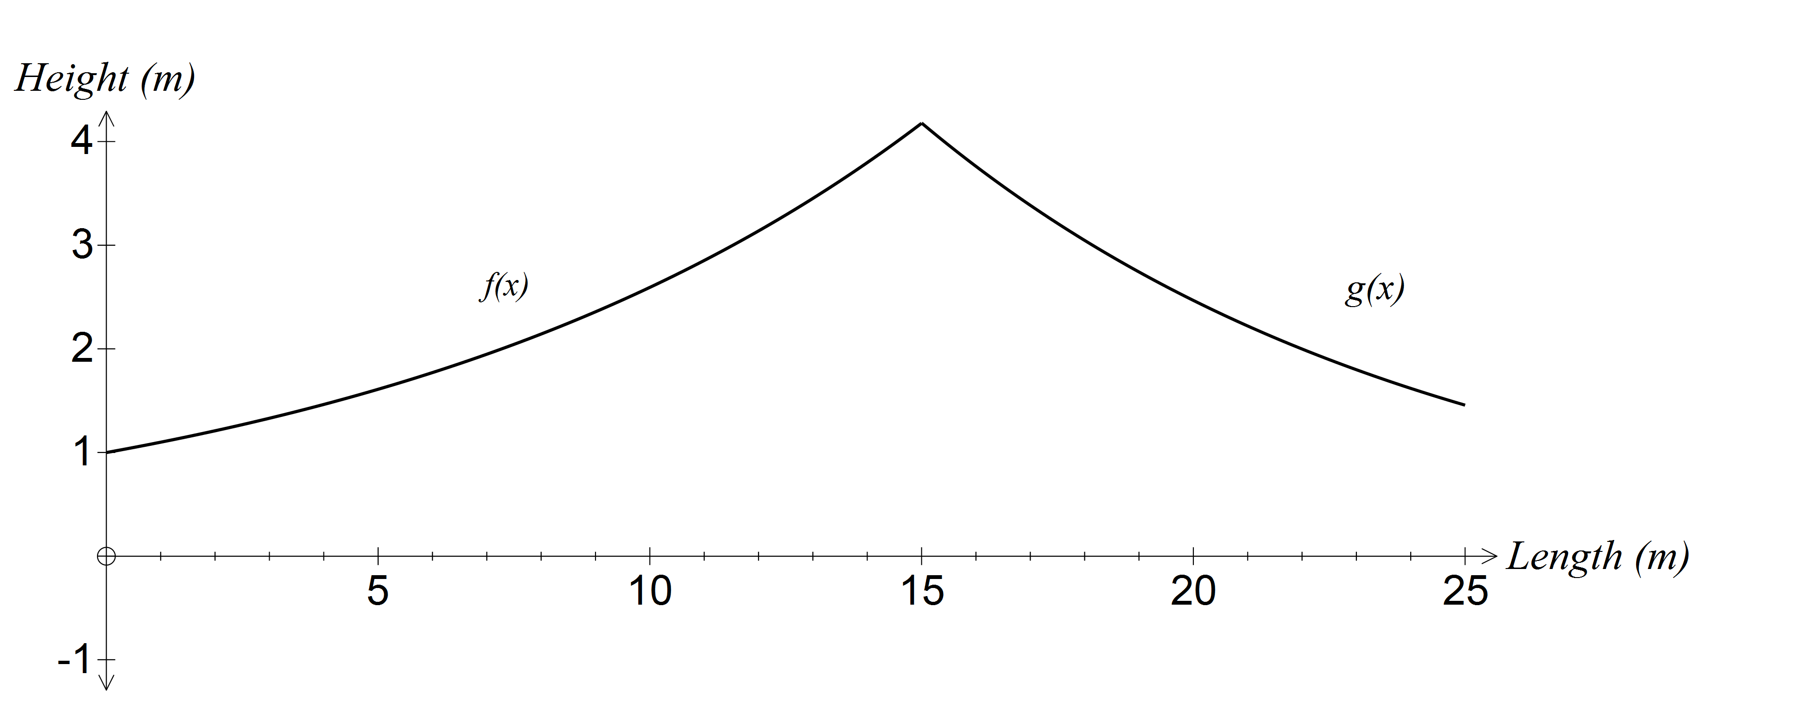

The top of the left side of the wall follows the function *f(x)* = 1.1*x* where 0 < *x* < 15.

The top of the right side follows the function *g(x)* = 20.3(0.9*x*) where 15 < *x* < 25.

This may be expressed as 

The *x*-axis represents ground level.

**Activity 1**

Draw *f(x)* and *g(x)* on the same axes and confirm that they intersect where *x* = 15.003.

Determine the maximum height of the wall.

How high is the wall on the far left? On the far right?

What would be the area of the front of the wall if the height was uniformly 4 m along the length of the wall?

Both the left and right sides of the wall are to be surfaced at the front by rectangular sheets of titanium. Each sheet is 20 cm wide.

**Left side of the wall**

The height of the rectangular sheet will be determined by the *y* value of the function that corresponds to the right end of each rectangular sheet as shown in the following diagram.





The area of each sheet of titanium used to surface the left wall is

Area = 0.2 × *f* (*a)*

The value of *a* corresponds to the value of *x* at the right end point of each sheet.

The values of *a* for the sheets of metal on the left hand side of the fence are:

0.2, 0.4, 0.6, 0.8, ….., 15 (metres)

**Question 1**

(a) How many metal sheets are required for the left hand side of the fence?

(b) Determine an expression for the area of the first metal sheet. Calculate this area.

(c) Determine a general expression for the area of each metal sheet on the left side.

(d) Justify the use of a geometric sequence to describe the area of successive sheets.

The sheets have to be extended by 10 cm below ground level.

(e) Calculate the area of the sheets below ground level.

(f) Calculate the total area of titanium sheeting required for this part of the fence.

**HINT : Calculate the sum of the terms of the geometric sequence and add on the total area below the ground.**

**Right side of the wall**

The right hand side of the wall is to be constructed in a similar way as the left hand side but the heights of the sheets of metal are to be measured using the left end point of each sheet with the height equal to the *y* value of the function 

Each sheet of titanium is 20 cm wide and there will be an extra 10 cm below ground level.

**Activity 2**

Determine the area of metal sheeting required for the right hand section of the wall.

**The project**

(a) Determine the range of the cost of the titanium given that the price per kilogram ranges from $15 to $30 and that titanium has a density of 4.5 grams per cm3.

(1m3 = 100cm x 100cm x 100cm)

(b) Given that the council budget is $15 000 and a minimum order of 5 kg is required, is the project feasible?

(c) If both sides of the wall were to be covered in titanium, but not the sides nor the top, how would the cost and feasibility of the project be affected?

(d) Show how sequences and the sum of a fixed number of terms can be used to

(i) express the heights of the titanium sheeting on each side of the wall

(ii) determine the areas of successive sheets of titanium on each side

(ii) determine the total area of titanium needed on each side of the wall

|  |  |  |  |  |  |  |
| --- | --- | --- | --- | --- | --- | --- |
| Name: | ___________________________________________ | | | | Date: *______* | |
| pact jpg1 | **Subject: METHODS MAT**  **Investigation 2, 2015**  **Topic: Arithmetic and geometric sequences** | | | | 43  = % | |
| **Weighting:** | *5% of the year.* | | | | |  |
| **Equipment:** | *Curriculum Council, Formula sheets, Calculators* | | | | | |
| **Important Information:**  *Although the take-home component is not worth any marks, it is essential in preparation for the in-class component. Knowledge and skills gained will be extended in the in-class validation component. This in-class validation will be completed under test conditions on the day in which this take-home component is due. The take-home component may be used when completing the in-class component. Contact will be made to parent(s) if the take-home component is not available for submission (at the start of the lesson).*  ***Answers should be rounded appropriately****. All working should be shown in the space provided. Your working should be in sufficient detail to allow your answers to be checked readily and for marks to be awarded for reasoning. Incorrect answers given without supporting reasoning cannot be allocated any marks. For any question or part question worth more than two marks, valid working or justification is required to receive full marks.*  *No pen, pencils, highlights etc. may be used during reading time. This time is to be used to read through the assessment and check that you understand what is being asked of you. You may speak with the teacher/supervisor during this time (by putting up your hand and waiting patiently for them to approach you) but you may only ask clarification questions and not how to solve the problems. After reading time has ended, you may not ask any more questions.* | | | | | | |
| **Take home component weighting:** | | *0% of the year* | **In-class component weighting:** | *5% of the year.* | | |
|  | | | | | | |

**Question 1 (12 marks)**

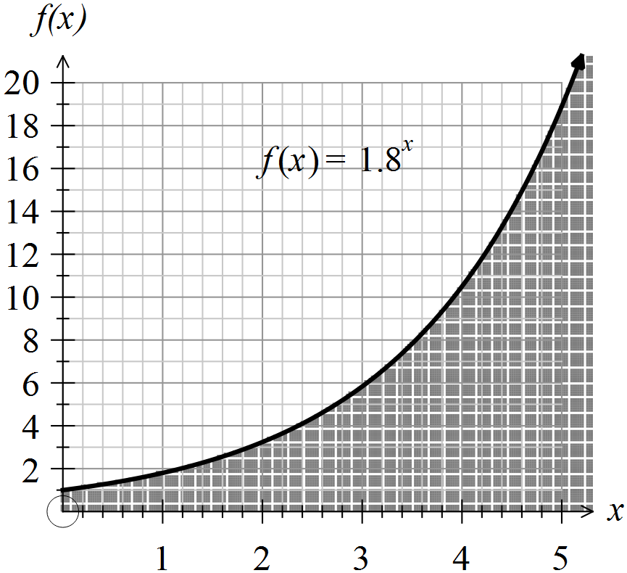

The graph shows an area under the curve . Consider the area under the curve for 0 < *x* < 5.0 as a series of rectangles with a width of 0.2 units.

The height of each rectangle is taken as  where *a* is the value of *x* at the right side of the rectangle; the last rectangle has a height of 1.8 5.0.

(a) Determine the height of the first rectangle. (2)

(b) Determine the area of the first rectangle. (2)

(c) How many rectangles make up this area? (2)

(d) The total area can be represented as a sum of the terms of a geometric sequence. Write down the first five terms of the sequence. (3)

(e) Determine the total area under the curve for 0 < *x* < 5.0. (3)

**Question 2 (16 marks)**

An irrational number like  that has an infinite number of decimal places can be drawn with some precision.

For a sequence defined recursively as  with  many of the terms are irrational numbers that have an infinite number of decimal places.

(a) Determine the first five terms of the sequence, expressing any irrational numbers in surd form. (4)

(b) To illustrate accurately on a diagram, a right isosceles triangle where the congruent sides are equal to one unit, can be drawn as shown in the diagram below.

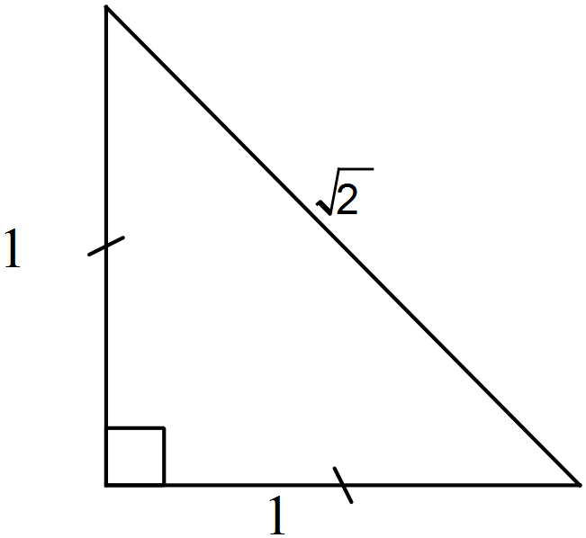

Explain why the length of the hypotenuse is $\sqrt{2}$ units in length. (2)

(c) Determine the length of the line PX. (2)

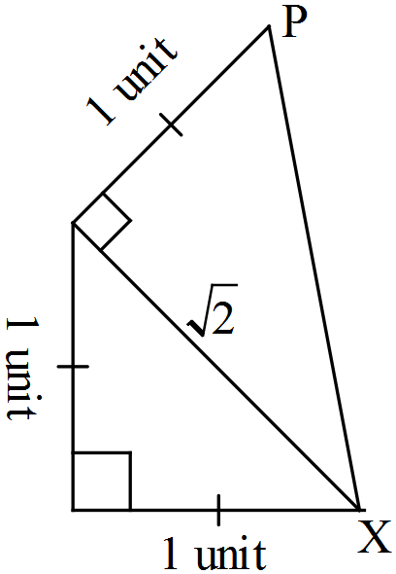

(d) Continue the pattern of completing triangles to illustrate on the diagram drawn above. Explain the process required. (4)

(e) How many triangles will have been drawn in this manner before the final hypotenuse is 64 units in length? Justify your answer. (4)

**Question 3 (15 marks)**

(a) Evaluate the following terms of this sequence, expressing your answers as mixed numerals. (5)

(i) 

(ii) 

(iii) 

(b) The next term in the sequence from part (a) is  . (4)

(i) Write an expression similar to those given above that could be used to determine this value.

(ii) Given that  is the second term of the sequence, state a recursive definition for this sequence.

(c) In decimal form the next three terms are:

1.625, 1.6154, 1.6190, 1.6176, 1.6182, 1.6180, 1.6181, 1.6180

Describe what appears to be happening to successive terms and explain why this is occurring. (3)

(d) The infinite sequence can be described as “One plus, one divided by, one plus, one divided by ….” and may be written as



The equation can be solved by substituting into the equation and obtaining  which simplifies to .

Solve the equation, giving your answers as two surds, α and β, where α > β. (3)